Section 1.1: Points, Lines and Planes

SOLs: None

Objectives: Students will be able to:
Identify and model points, lines and planes
Identify collinear and coplanar points and intersecting lines and planes in space

Vocabulary:
Point – a location in space; usually named by coordinate location
Line segment – a collection of collinear points between two points
Line – a collection of points, defined by two points
Collinear – points on the same line are called collinear
Plane – flat surface made up of points; defined by at least three points (or two intersecting lines)
Coplanar – points lying on the same plane are called coplanar
Space – is a boundless, three dimensional set of all points

Key Concept:

Five Minute Review:

- 6x + 45 = 18 – 3x

- x² – 45 = 4
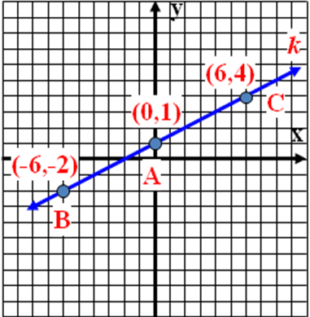
- (3x + 4) + (4x – 7) = 11

- (4x – 10) + (6x +30) = 180

- Find the slope of the line k.

- Find the slope of a perpendicular line to k
a. ½ b. 2 c. -½ d. -2
Examples:
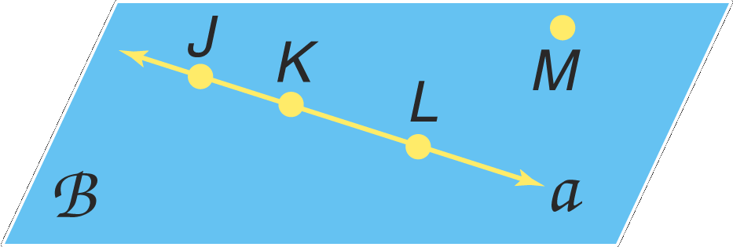
1. Use the figure to name a line containing point K.

2. Use the figure to name a plane containing point L.

3. Find a line containing point X

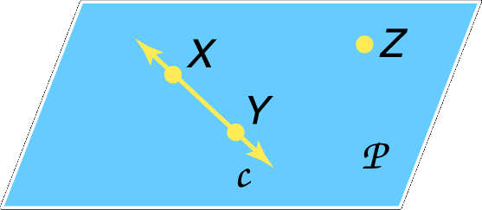

4. Find a plane containing point Z

5. Name a geometric object that could represent the following:

a. a colored dot on a map used to mark the location of a city

b. the ceiling of your classroom

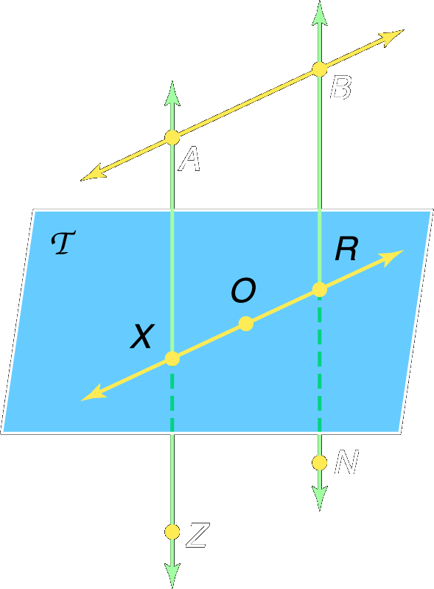
c. the railing on a stairway

6. How many planes appear in this figure?

7. Name three points that are collinear.

8. Are points X, O, and R coplanar? Explain.

Concept Summary:
Two points determine a line
Three noncollinear points determine a plane.

Homework: pg 9,10: 7-8, 13, 15, 17, 22-23, 32, 34-35

Skills for Next Section: Measuring length
Section 1.2: Linear Measure and Precision

SOLs: The student will
G.11 Construct a line segment congruent to a given line segment, the bisector of a line segment, a perpendicular to a given line from a point not on the line, a perpendicular to a given line at a point on the line, the bisector of a given angle, and an angle congruent to a given angle.

Objectives: Students will be able to:
Measure segments and determine accuracy of measurement
Compute with measures

Vocabulary:
Line Segment -- has two end points and can be measured
Precision – is equal to one-half the smallest unit on the measuring tool
Congruent – when segments have the same measure, they are congruent (≅)
Equal – numbers (variable and equations) and measurements of things are equal if the have the same values

Key Concept:
Numbers (distances) are equal; things (line segments, angles, polygons) are congruent

Five Minute Review:

Refer to the figure for questions 1 through 5.
- Name three collinear points.

- What is another name for AB?

- Name a line in plane Z.

- Name the intersection of Planes Z and W.

- How many lines are in plane Z?

- Three lines are coplanar. What is the greatest number of intersection point that can occur?
a. 2 b. 3 c. 4 d. 5

Examples:

1: Find the precision for 32¾ inches. Explain its meaning.

- Find the precision for each measurement. Explain its meaning.

  - 88 millimeters

  - 7 ⅝ inches

- Find LM

- Find x and ST if T is between S and U, ST = 7x, SU = 45, and TU = 5x – 3.

5. Find a and AB if AB = 4a + 10, BC = 3a – 5, and AC = 19.

Concept Summary:
The precision of any measurement depends on the smallest unit available on the measuring device
The measure of a line segment is the sum of the measure of its parts

Homework: pg 16-17; 5, 8, 25, 29-31

Skills for Next Section: Distance Formula
Section 1.3: Distance and Midpoints

SOLs: None

Objectives: Students will be able to:
Find the distance between two points
Find the midpoint of a (line) segment

Vocabulary:
Midpoint – the point halfway between the endpoints of a segment
Segment Bisector – any segment, line or plane that intersects the segment at its midpoint

Key Concept:
________________
Distance formula: √[x₂ – x₁]² + [y₂ – y₁]²
Midpoint of segment with endpoints (x₁, y₁) and (x₂, y₂) is ([x₁+x₂]/2, [y₁+y₂]/2)

Five Minute Review:
- Find the precision for a measurement of 42 cm.

- If M is between L and N, LN = 3x – 1, LM = 4, and MN = x – 1, find x and MN?
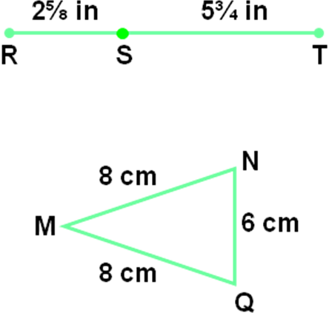
- Use the figure to find RT.

Use the figure to determine whether each pair of segments is congruent.
- MN, QM

- MQ, NQ

- If AB ≅ BC, AB = 4x – 2 and BC = 3x + 3, find x.
a. 5 b. 4 c. 3 d. 2
Examples:

1. Use the number line to find AX.

-6 -5 -4 -3 -2 -1 0 1 2 3 4
A X

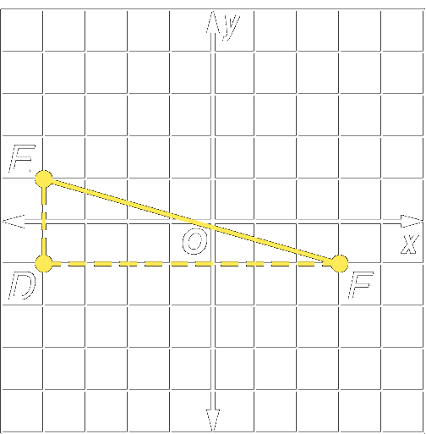
- Find the distance between E(-4, 1) and F(3, -1).

3. The coordinates on a number line of J and K are –12 and 16, respectively. Find the coordinate of the midpoint of line segment JK.

4. Find the coordinates of M, the midpoint of line segment GH, for G(8, –6) and H(–14, 12).

5. Find the coordinates of D if E(–6, 4) is the midpoint of line segment DF and F has coordinates (–5, –3).

Concept Summary:
Distances can be determined on a number line or a coordinate plane by using the Distance Formula
The midpoint of a segment is the point halfway between the segment’s endpoints

Homework: pg 25-27; 9, 12-15, 20, 23, 37-38, 57, 63, 65

Skills for Next Section: angles and measurement
Section 1.4: Angle Measure

SOLs: The student will
G.3 The student will solve practical problems involving complementary, supplementary, and congruent angles that include vertical angles, angles formed when parallel lines are cut by a transversal, and angles in polygons.

Objectives: Students will be able to:
Measure and classify angles
Identify and use congruent angles and the bisector of an angle

Vocabulary:
Degree – one three hundred and sixtieth of a circle
Ray – part of a line with one end point
Opposite rays – are collinear rays with the same end point (& form a 180 degree angle)
Sides – composed of rays
Angle is formed by two noncollinear rays that have a common endpoint (vertex)
Vertex – is the common endpoint
Interior – area between the two rays that form the angle
Exterior – area not between the two rays that form the angle
Special types of angles:
Right angle – measure of the angle equal 90 degrees
Acute angle – measure of the angle is less than 90 degrees
Obtuse angle – measure of the angle is greater than 90 degrees (but less than 180)
Angle Bisector – a ray that divides an angle into two congruent angles

Key Concept:
Sum of angles (around a single point) in a circle = 360 degrees
Five Minute Review:
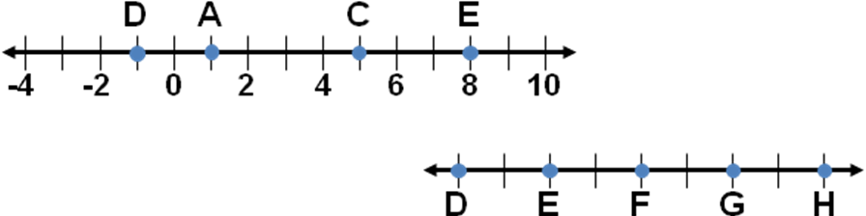
Use the number line to find each measure.
- AC

- DE

- Find the midpoint of EG

- Find the distance between P (-2,5) and Q (4,-3).

- Find the coordinates of R, if M (-4,5) is the midpoint of RS and S has coordinates of (0,-10)?

- What is the perimeter of ∆ DEF if its vertices are D(-2,-6), E(-2,6), and F(3,-6)?
a. 12 b. 13 c. 17 d. 30
Examples:
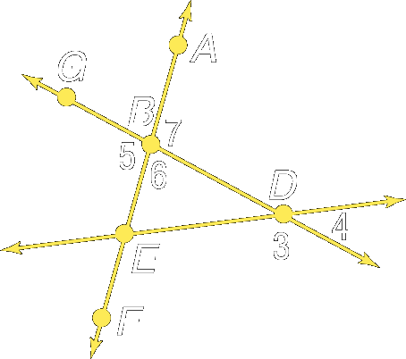
Given the following figure:

1. Name all angles that have B as a vertex.
2. Name the sides of angle 5.
3. Write another name for angle 6.

Given the following figure:
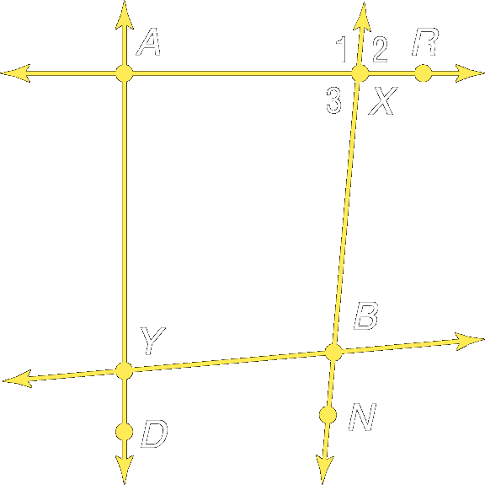

4. Name all angles that have X as a vertex.
5. Name the sides of angle 3.
6. Write another name for angle 3.
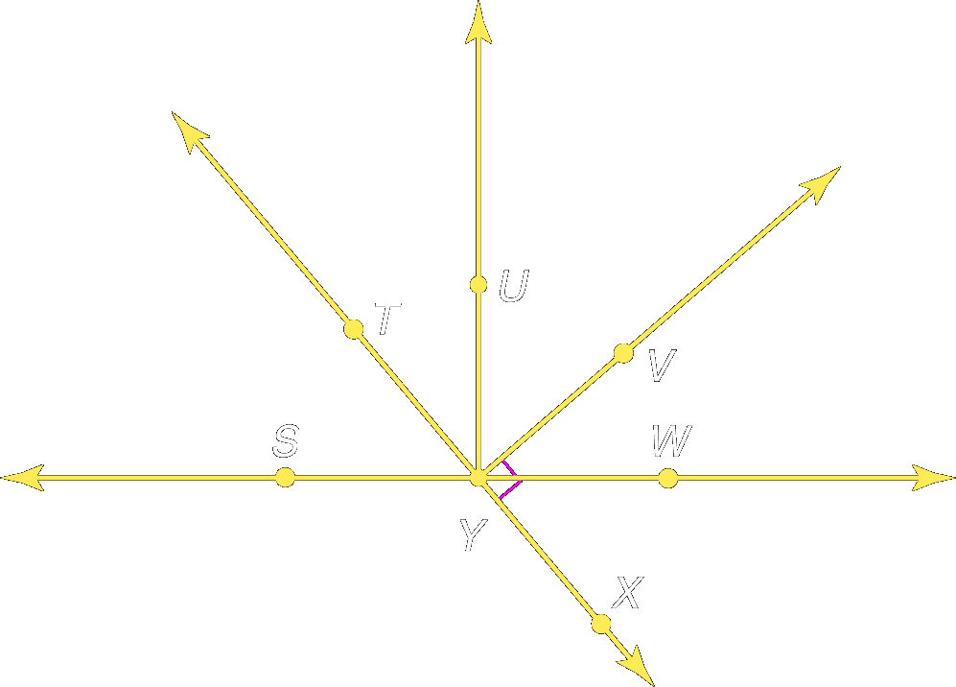

Given the following figure:

7. Measure angle TYV and classify it as right, acute, or obtuse.
8. Measure angle WYT and classify it as right, acute, or obtuse.

Given the following figure, with lines ZE and CX, and ray ZD, measure each angle named, and classify it as right, acute, or obtuse.
C
Z
X
D
E

9. Angle CZD
10. Angle CZE
11. Angle DZX

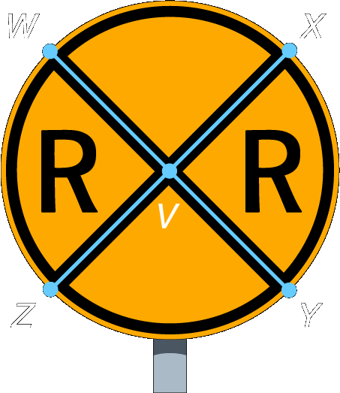
12. A railroad crossing sign forms congruent angles. In the figure, ∠WVX is congruent to ∠ZVY.
If m∠WVX = 7a + 13 and m∠ZVY = 10a – 20, find the actual measurements of ∠WVX and ∠ZVY.

Concept Summary:
Angles are classified as acute, right, or obtuse according to their measure
An angle bisector is a ray that divides an angle into two congruent angles

Homework: pg 33-35; 9, 11, 13, 14, 20, 24-26, 50

Skills for Next Section: angle relationships
Section 1.5: Angle Relationships

SOLs: The student will
G.3 The student will solve practical problems involving complementary, supplementary, and congruent angles that include vertical angles, angles formed when parallel lines are cut by a transversal, and angles in polygons.

Objectives: Students will be able to:
Identify and use special pairs of angles
Identify perpendicular lines

Vocabulary:
Adjacent angles – two coplanar angles that have a common vertex, a common side, but no common interior points
Linear pair – a pair of adjacent angles whose noncommon sides are opposite rays
Vertical angles – two non adjacent angles formed by two intersecting lines
Vertical angles are congruent (measures are equal)!!
Complementary Angles – two angles whose measures sum to 90
Supplementary Angles – two angles whose measures sum to 180
Perpendicular – two lines or rays are perpendicular if the angle (s) formed measure 90°

Key Concept:

Five Minute Review:
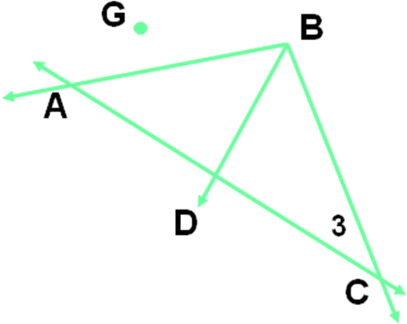
Refer to the figure for questions 1 through 5.
- Name the vertex of ∠3.

- Name a point in the interior of ∠ACB.

- Name the sides of ∠BAC

- Name an acute angle with vertex B

- If BD bisects ∠ABC, m∠ABD = 2x + 5 and m∠DBC = 3x – 16, find m ∠ABD.

- If P is in the interior of ∠MON and m∠MOP = ½ m∠MOP, what can you conclude?
a. ∠PON ≅ ∠NOM b. ∠MON is an acute angle
c. m∠MOP > m∠PON d. OP is the angle bisector of ∠MON

Examples:
Given the following figure:
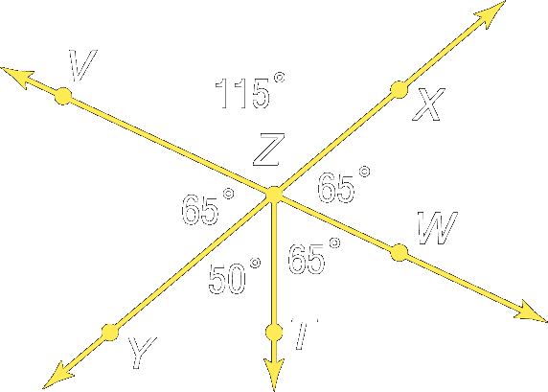

1: Name two angles that form a linear pair.
2. Name two acute vertical angles.

Given the following figure, name an angle pair that satisfies each condition.
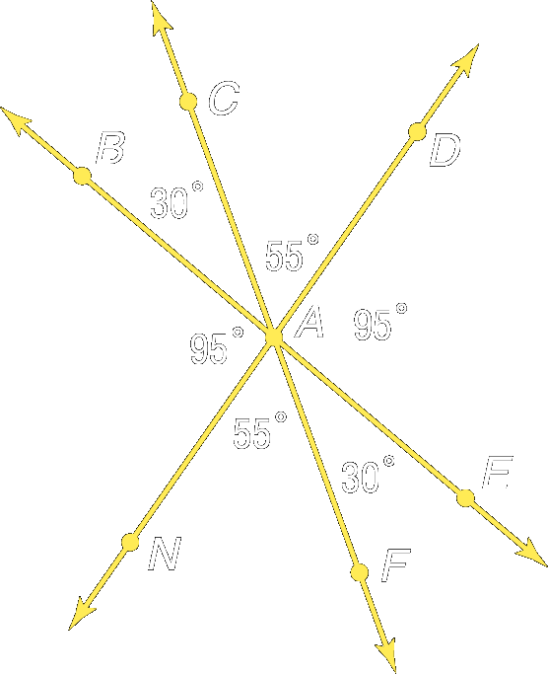

3. Two acute vertical angles.
4. Two adjacent angles whose sum is less than 90 degrees.

5. ALGEBRA: Find the measure of two supplementary angles if the measure of one angle is 6 less than five times the other angle.

6. Using the following figure, find x and y such that lines AD and CE are perpendicular.
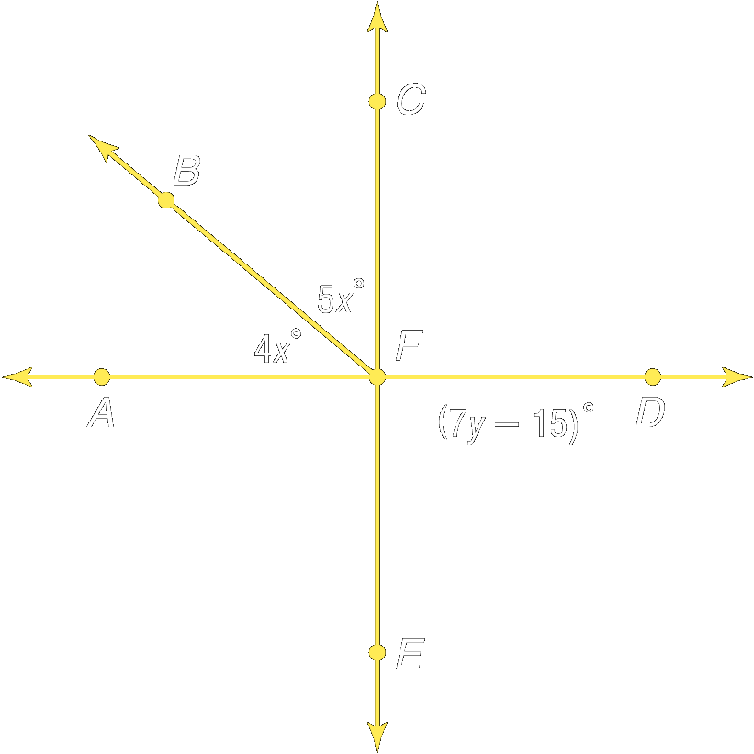

Concept Summary:
There are many special pairs of angles such as adjacent angles, vertical angles, complementary angles, supplementary angles, and linear pairs.

Homework: pg 41-43; 11-16, 21, 32-33, 44-49

Skills for Next Section: polygons
Section 1.6: Polygons

SOLs: None

Objectives: Students will be able to:
Identify and name polygons
Find perimeters of polygons

Vocabulary:
Polygon – a closed figure whose sides are all line segments
Concave – any line aligned to the sides passes through the interior
Convex – not concave (“side line” passes through interior)
n-gon – a polygon with n sides
Regular polygon – a convex polygon with all segments congruent & all angles congruent
Irregular polygon – not regular
Perimeter – the sum of the lengths of sides of the polygon
Key Concept:

Sides | Name
3 | Triangle
4 | Quadrilateral
5 | Pentagon
6 | Hexagon
7 | Heptagon
8 | Octagon
9 | Nonagon
10 | Decagon
12 | Dodecagon
N | N - gon

Five Minute Review:

Refer to the figure for questions 1 through 3.
48°
A
B
C
D
E
- Name two acute vertical angles.

- Name a linear pair whose vertex is E.

- Name an angle supplementary to ∠BEC.

- If ∠1 and ∠2 are supplementary and the measure of ∠1 is twice that of ∠2, then find the measures of both angles.

- If RS ⊥ ST and SV is the angle bisector of ∠RST, what is the m∠TSV?

- If two angles are congruent and supplementary, then they must be
Examples:
Given the following figures, name each polygon by its number of sides, and classify it as concave or convex, and regular or irregular.

1:
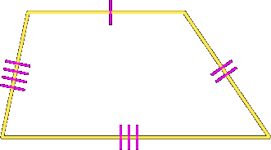
2:
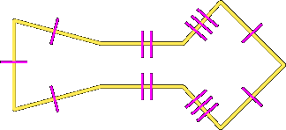

3. A masonry company is contracted to lay three courses of decorative brick along the foundation of a new house given the dimensions below. Find the perimeter of the foundation.
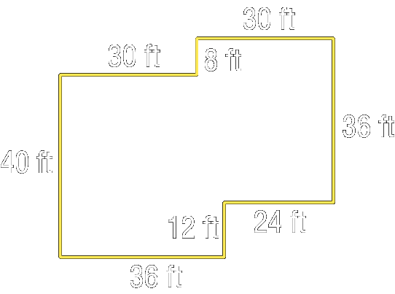

4. The width of a rectangle is 5 less than twice its length. The perimeter is 80 centimeters. Find the length of each side.

Concept Summary:
A polygon is a closed figure made of line segments
The perimeter of a polygon is the sum of the lengths of its sides

Homework: pg 49-50: 12-21, 29-31, 33

Skills for Next Section: Review of Chapter 1

